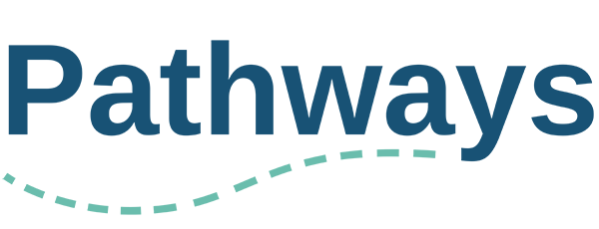

# Expression of Interest: STEP TWO

Hello. You've landed on this page because a member of your organization has completed the first step of the Expression of Interest form to participate in the Pathways program.

You can learn more about the Pathways program here: https://manypathways.ca/program-details/

Questions about the program can be directed to info@manypathways.ca.

### This step of the EOI process

Now that we know a bit about your organization, we need to better understand the context and learning goals for each of the proposed participants from your organization.

That's why you're here.

### Please note:

* ***Confidentiality*** - Your answers for this first section of the EOI is for the Pathways leadership and program guides to better understand how we can support your individual needs, if invited into the program.
* ***"Participant"*** - We use the term "participant" broadly to refer both to the participating organization and participating individuals, with the understanding that they may overlap or diverge at different times.
* ***A program to support, not assess*** - For clarity, the Pathways program is intended to support participants on their learning journey; not to assess or judge participants for not being further along than they think they should be.

*All questions with an asterisks* requires a response.*

## About You

* Q1 Your Name *
* Q2 Your Pronouns
* Q3 Your Email *
* Q4 Name of the Organization or Collective that is applying to Pathways *
* Q5 Who are you in relation to the organization and how long have been with them? *

## Getting to know you

**Q6 What brings you to Pathways? What are you and your organization hoping to achieve through a program like this? \*** *(Max 150 words; no minimum)*

*We have found that identifying and understanding the “why” contributes to a successful Pathways experience. For some this may be external factors such as feeling pressure from funders or the community, for others it may be more personal or internal to the organization such as new leadership or strategic focus.*

**Q7 What are you building from? What are the strengths, resources, and/or groundwork that will contribute to your organization's ability to integrate what you learn through Pathways? \*** *(Max 150 words; no minimum)*

*We recognize that every participant is at a different place in their equity and access work. Pathways seeks to meet each participant where they are. The goal of this question is to gain an understanding of the resources you have available to dedicate to this work, not to assess your progress.*

**Q8 Are there are any tensions within your organization or community around equity and access (or otherwise) that could impede the implementation of change? If so, please share. \*** *(Max 150 words; no minimum)*

*Please share any existing challenges or tensions that would be helpful for us to know as we support you through our year together. Any information shared with Pathways is kept in confidence.*

**Q9 In your own words, describe the communities your organization serves. Are there communities that you wish to serve better? \*** *(Max 150 words; no minimum)*

**Q10 (optional) Please share any access needs you have that would better support your full participation in the program** *(eg. ASL interpretation, captions for online meetings, time of day when meetings take place)*

**Q11 Confirm you agree to the following statements:**

* The information included on this form is true and complete
* I am willing to provide feedback and contribute to the shaping of this program
* I am interested and invested in ongoing learning about access and equity

When complete, please submit this Step One EOI to [info@manypathways.ca](mailto:info@manypathways.ca).

**Note:** Shortlisted organizations will be invited to a meeting with the Program Director by the end of November. All applicants will be contacted regarding their application status by December 1, 2024.

If you have any questions, please contact the Pathways program at [info@manypathways.ca](mailto:info@manypathways.ca)